Full Paper Title

First A. Author¹, Second B. Author and Third C. Author
My Institute/Company
Address, City, Country
E-mail: First.Author@institution.org
Keywords: Dams; Concrete; Seismic hazard; Dynamic monitoring
Abstract. This document presents the information and instructions needed to prepare a Full Paper for the 3rd Meeting of EWG Dams and Earthquakes. In order to achieve graphical consistency, the Full Paper should follow this template structure and format. The paper should be written in English. The number of recommended pages is from 6 to 12.
The first page should start with the paper’s title, authors, corresponding author affiliation, address and e-mail, followed by keywords and abstract. If suitable, the introduction starts after the abstract.

INTRODUCTION
Papers should clearly describe the background of the subject, the authors work, including the methods used, results and concluding discussion on the importance of the work.

Submission
All Submissions must be done through the online conference easychair management system: https://easychair.org/conferences/?conf=ewg2019. The papers should be submitted in Word format (.docx). More information for authors is available in the conference website: http://ewg2019.lnec.pt/.

title, AUThORS, affiliation, keywords
The first page must start with the title, authors’ names, first author details (affiliation, address and e-mail), followed by keywords and abstract. Second, third and other authors’ affiliation should be included in a footnote.

Title
The title must be centered and written in uppercase using Times-Roman bold, 14 point. If the title extends over several lines, the lines must be single spaced.

Authors
The authors’ names must include the first name, middle initials (if it is the case) and the last name. These must be centered and written with 12 point bold Times-Roman. The authors’ names must be located 12 point below the last title line.

Affiliation
The first author affiliation must be centered, written with 11 point Times-Roman, and located 12 point below the authors’ names.

Keywords
From four to eight keywords must be provided. These are written with the Times-Roman 12 point font, separated from each other by a semicolon. The expression Keywords must be written in 12 point bold Times-Roman font.

Abstract
The typeface used for the abstract is a 12 point italic Times-Roman. The word Abstract, written in 12 point bold Times-Roman, must appear in the beginning of the first line. The abstract text is justified and written 12 point below the last line of the keywords, as shown in the first page of these instructions.

sections

Main sections
The titles of the main sections must be flushed left and written with uppercase bold Times-Roman 12 point font. A 12 point space before and after the section title must be specified. In order to avoid orphans on the text make sure that at least three lines of text are typed after the section title and before any page break. The graphical appearance of the publication will profit from your care.

Subsections
The subsection titles must be written flushed left, with a bold Times-Roman font, 12 point. Only the first letter of the title is uppercase, being all others lowercase. Spaces of 12 point before and 6 point after the subsection titles must be specified. In order to avoid orphans on the text make sure that at least two lines of text are typed after the subsection title and before any page break.

TEXT
The normal text of the contribution must be typed single spaced, justified, and using 12 point Times-Roman font. Moreover the text must be in a single column. The first line of each paragraph must be indented 1.0 cm and no additional spacing between paragraphs must be given.

page numbers
The page numbers should be included by the authors. The page number must be centered and placed below the print area (not inside). The font should be 11 point Times-Roman.

figures
All figures must be numbered consecutively and have a corresponding caption, as shown in Figure 1. The caption is centered and written using 10 point Times-Roman, using upper and lowercase. The distance between each figure and its corresponding caption must be 6 point while the distance from the top of the figure and from the caption to the text must be 12 point. The figures must be included in the text. Do not supply the figures in the end of the paper.

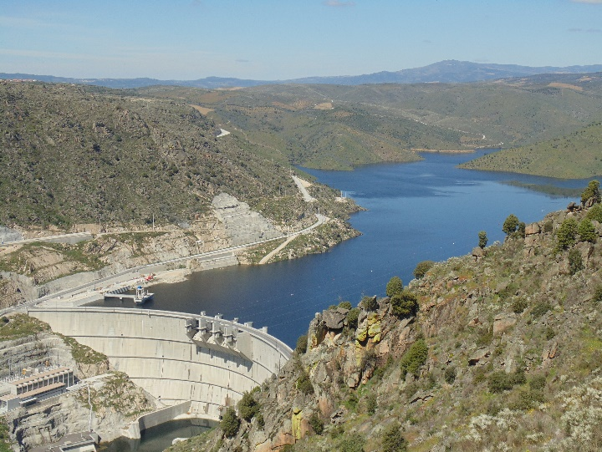
Figure 1: Image example

equations
Each equation must be numbered in a sequential fashion, using Arabic characters included in parenthesis. The equations must be centered and a 6 point space between the text that precede and follows them must be given.
(1)
(2)

tABLES
All tables must be numbered consecutively and have a corresponding caption. The caption is centered and written using 10 point Times-Roman, using upper and lowercase.
Table 1: Example of a table construction
Column 1 | Column 2 | Column 3
C11 | C12 | C13
C21 | C22 | C23
C31 | C32 | C33
C41 | C42 | C43
C51 | C52 | C53
The distance between each table and its corresponding caption must be 6 point while the distance from the top of the table to the text above and from the caption to the text below must be 12 point. The tables must be included in the text.

format for the references
In the text, the references citations must be provided using square brackets [1], and grouped in the end of the paper by numerical order, as shown in the end of these instructions. The numbering by which they are referred must also be consecutive and by the order they appear in the text.

conclusions
Conclusions should systematize the most important propositions of the paper and highlight the main features, new contributions and its practical implications.

references
[1] R.E. Roberson and R. Schwertassek, Dynamics of multibody systems, Springer-Verlag, Berlin, Germany (1988).

Second Author Institution Name, e-mail
Third Author Institution Name, e-mail

